Eastern Mediterranean University - Faculty of Business and Economics
Department of Politics and International Relations
2024-2025 Spring Semester
Final Exam (20%)

PSIR 220: Research Design– Final Examination
Course Code: PSIR 220
Level: Undergraduate
Total Marks: 20
Duration: 2 Hours (120 minutes)
Instructor: Dr. Erol Kaymak
Name: ______________________________________________________

Student Number: _____________________________________________

Instructions: Answer questions from Sections B, C, and D on the answer sheets attached.

Section A: Multiple Choice & Basic Concepts (10 points)
(Each question is 0.5 points; 20 questions total)
1. A Research Question should be:
A) Broad and general
B) Narrow and specific
C) Opinion-based
D) Impossible to answer
2. A Hypothesis is:
A) A proven fact
B) An educated guess
C) A random idea
D) A summary of findings

3. APA citation for a paper by Smith & Brown (2020) within text is:
A) (Smith and Brown, 2020)
B) (Smith & Brown, 2020)
C) (Smith, Brown 2020)
D) (Smith-Brown, 2020)
4. True or False: “Necessary causality” means a factor must be present for an outcome to occur.
5. Fill in the blank: Identifying a gap in literature means finding something _______ that previous studies have overlooked.
6. Which of the following is an example of operationalizing the concept “trust in government”?
A) Asking about trust in banks
B) Measuring government revenue
C) Using a survey question: “I trust the local government to act fairly”
D) Interviewing politicians
7. Internal validity refers to:
A) The ability to generalize findings
B) The accuracy of statistical software
C) Confidence that changes in the DV are due to the IV
D) Sample size representativeness
8. External validity is concerned with:
A) Precision in variable definitions
B) Generalizability of findings
C) Sample size errors
D) Lack of control variables
9. Which of the following is a Dependent Variable?
A) Type of media exposure
B) Age of respondent
C) Vote choice
D) Survey method
10. The Independent Variable in a study on campaign ads influencing turnout is:
A) Level of turnout
B) Political party identification
C) Exposure to ads
D) Voter age
11. What is stratified sampling?
A) Sampling without any grouping
B) Random sampling from pre-identified subgroups
C) Interviewing everyone in a village
D) Sampling based on social media usage

12. Which of the following would likely threaten external validity?
A) Random assignment
B) Convenience sampling
C) Large sample size
D) Controlling for confounders
13. An example of a directional hypothesis is:
A) “There is a relationship between education and voting.”
B) “Education increases the likelihood of voting.”
C) “Voting causes education.”
D) “Both variables are independent.”
14. Fill in the blank: A ______ variable explains part of the relationship between the IV and DV.
15. In a scatterplot, heteroskedasticity refers to:
A) Data being evenly spread
B) Varying spread of residuals at different levels of the IV
C) Straight lines through points
D) No outliers present
16. Which statistic is most appropriate for testing a relationship between a binary IV and a 5-point Likert DV?
A) Chi-square
B) T-test
C) Correlation coefficient
D) ANOVA
17. Convenience sampling is:
A) The most reliable method
B) Prone to bias
C) Always random
D) More expensive than stratified sampling
18. The best way to reduce nonresponse bias is:
A) Increase sample size
B) Remove outliers
C) Follow up with nonrespondents
D) Use panel surveys
19. Which of these terms means “adequately captures the concept being measured”?
A) Reliability
B) Validity
C) Randomness
D) Variance
20. Which of the following is NOT a component of a strong literature review?
A) Descriptive summary of each article
B) Thematic organization
C) Identifying theoretical gaps
D) Connecting literature to your research question

Section B: Definitions (5 points, 2.5 points each)
1. Define Operationalization and provide a simple political example.
2. Define External Validity and mention one threat to it.

Section C: Data Interpretation (5 points)
Refer to Figure 1: Age vs. Voter Participation (scatterplot provided).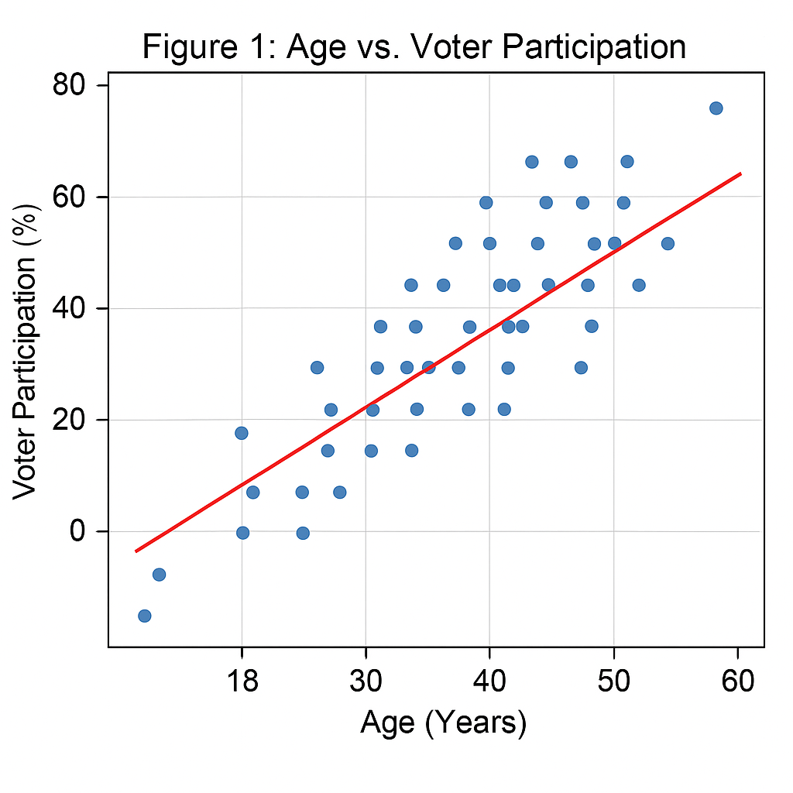
1. What kind of relationship is shown between age and voter participation?
2. Estimate the direction (positive/negative) and approximate slope of the trendline.
3. Are there any visible outliers? If so, what might they indicate?
4. What could be one omitted variable that explains both age and participation?
5. Does the pattern suggest increasing or decreasing variance with age? Explain.

Section D: Research Design Scenario (5 points)
Scenario: You are studying whether televised youth debates increase young voters’ turnout in the 2025 Northern Cyprus parliamentary elections. You will use a post-election survey of people aged 18–30 across three urban districts.
1. Identify the Independent Variable (IV) and how it might be measured.
2. Identify the Dependent Variable (DV) and one suitable survey item.
3. Propose a sampling method and justify your choice.
4. Name one control variable and explain its inclusion.
5. Choose between a cross-sectional or panel design and justify.

